 | Epsom & Ewell F.C.  v  Mole Valley SCR  Saturday 21st August 2010
For this afternoon’s League match we welcome Mole Valley SCR, today's officials, and of course our own regular supporters to Moatside.

Our visitors have had a meteoric rise to this level and we meet them for the first time today, following their promotion as Combined Counties League Division One Champions. They have also had a fine start to their season at the top flight and remain unbeaten after three League games, drawing 2-2 at Badshot Lea to follow their 4-1 wins over Egham Town and Ash United.

However, we aren’t doing so badly ourselves right now. Three straight wins, eleven goals scored and none conceded have reduced the opening day slip at Sandhurst to a distant memory. We have also got off to a good start here at our new Moatside home. Two matches and two wins have confidence sky-high, and I’m sure Lyndon, Tony and Barry will be doing their best to ensure that this doesn’t become over-confidence.

Our win over Shoreham in the F.A.Cup has earned us another home tie, and in seven days our old friends from Flackwell Heath will be visiting us again. When we dropped into Step Five football a few seasons back, we knew that teams like Flackwell would not be met so often because of the geographical boundaries, so it will be nice to see them again.

The Supporters Fund-Raising is going well, and on sale today for the first time is the Limited Edition 108 page booklet covering the 50 Epsom Legends. It costs £10 and every penny after printing costs will go to the cause. Why not buy one! Also available for the last time in this scoring period are the Golden Goal Bingo Tickets. We are scoring quite a few goals right now, so the chances of winning are higher right now. On sale today in one of our envelopes will be ticket 101, which has four numbers already on the card.

But back to this afternoon’s game, which I believe will be an entertaining one with two teams that are playing well right now. Let’s hope so!

Enjoy the game!

Richard

Cover photo by Gemma Jarman

The players catch a quick shower just before the kick off of the Shoreham F.A.Cup tie last Saturday!

Cherry Red Records Combined Counties League
Premier Division Table
inc Wednesday 18th August | P | W | D | L | F | A | Pts | GD
Chertsey Town | 3 | 3 | 0 | 0 | 8 | 1 | 9 | +7
Mole Valley SCR | 3 | 2 | 1 | 0 | 10 | 4 | 7 | +6
Molesey | 3 | 2 | 1 | 0 | 7 | 3 | 7 | +4
Sandhurst Town | 3 | 2 | 1 | 0 | 6 | 3 | 7 | +3
Chessington & Hook | 3 | 2 | 1 | 0 | 4 | 2 | 7 | +2
Epsom & Ewell | 3 | 2 | 0 | 1 | 9 | 3 | 6 | +6
Camberley Town | 3 | 2 | 0 | 1 | 8 | 4 | 6 | +4
Guildford City | 3 | 1 | 2 | 0 | 6 | 4 | 5 | +2
Colliers Wood Utd | 3 | 1 | 1 | 1 | 6 | 6 | 4 | 0
Badshot Lea | 3 | 1 | 1 | 1 | 5 | 6 | 4 | -1
Cove | 2 | 1 | 0 | 1 | 8 | 2 | 3 | +6
Egham Town | 2 | 1 | 0 | 1 | 5 | 4 | 3 | +1
Ash United | 2 | 1 | 0 | 1 | 2 | 4 | 3 | -2
Croydon | 3 | 1 | 0 | 2 | 2 | 5 | 3 | -3
Dorking | 2 | 1 | 0 | 1 | 1 | 5 | 3 | -4
Banstead Athletic | 3 | 0 | 1 | 2 | 1 | 3 | 1 | -2
Horley Town | 2 | 0 | 1 | 1 | 1 | 5 | 1 | -4
Bookham | 3 | 0 | 1 | 2 | 1 | 7 | 1 | -6
Raynes Park Vale | 3 | 0 | 1 | 2 | 3 | 11 | 1 | -8
Hanworth Villa | 3 | 0 | 0 | 3 | 1 | 4 | 0 | -3
Wembley | 3 | 0 | 0 | 3 | 1 | 9 | 0 | -8

Lucky Day? – 21st August
Played 11 - Won 5 Drawn 2 Lost 4 – F23 A18 - PPG 1.55 – Above Average

Club record against Mole Valley SCR
This is our first ever meeting
From behind the goal
Epsom & Ewell 5-0 Dorking F.C. – Combined Counties League
Tuesday 17th August 2010

What a week! In the last seven days we have played three, won three, scoring eleven goals and conceded none. This was a wonderful performance from start to finish as our visitors never got a chance to gain a foothold in the game.

An unchanged starting eleven for the third straight game was not exactly a surprise after the previous two results, and the players are now beginning to settle into their roles. Within a minute we were almost ahead when Mark Jarman outpaced his man through the middle but skewed his shot wide when he had more time than he realised. Dorking were forced into an early substitution and shortly afterwards Kyle Hough grazed the outside of the post when he was put through by Ramzi Bedj Bedj.

In the past the supporters could have been worrying at this point, as we hadn't beaten Dorking at home for nearly ten years, but after 15 minutes any concerns were forgotten. Tony Cuff whipped the ball in to the unmarked Darren Smith, who met it with a firm downward header that was only half saved before the ball crept over the line.

Chances continued on a regular basis. Jamie Hatfield was wide with a well-struck shot from distance, while Smith was just over with a header, but after 36 minutes we had extended our lead. Another Cuff free kick was competed for at the back post and Jarman headed the ball back, and just inside the far post. Eight minutes later Smith was clean through but this time, the keeper made a fine save to deflect the ball just wide.

Within minutes of the restart one of our players was fouled right on the edge of the box. Whilst it was a definite foul, I was not convinced that it actually happened inside the area. Fortunately, the referee was more certain and Hough struck the penalty away, glancing the post on its way through after 48 minutes.

In the past we might have settled for three-nil, but not any more. The players poured forward at every opportunity, whilst remembering their defensive duties when required. Smith was just wide with a volley after a bit of ball juggling, and a Jarman flick was just pushed away by the keeper, who had a good game.

We made it 4-0 with yet another Cuff free kick that reached Charlie West at the back post, and his header went in, aided by a slight deflection after 71 minutes. However, the party piece was still to come. On Saturday Cuff had three assists and had three more this day, but he wasn't finished. After 76 minutes he took a corner. And scored with it! A fantastic outside of the foot delivery that sailed over everyone and dropped into the far side netting, almost like a golf ball gets chipped onto the green and stops there.

We still had time for substitute Matt Fowler to curl one for the top corner, but the keeper was just able to palm the ball away, while he and Jarman combined well but the latter's shot was well saved again. Right near the end Joe Paris made a great run to meet Fowler's deep cross but he couldn’t control his potential net busting header, which was just wide.

This was one of the best Epsom & Ewell performances I have witnessed in 29 years as a supporter. The skill and passing was fantastic, while the work rate and finishing was superb, and only the keeper prevented this possibly reaching double figures. On Saturday Dorking had lost 5-0 in the F.A.Cup but the reports said that they had more chances, while Bracknell took the five they had. I don't think they will be able to make the same excuse this time.

Recent Results and Fixtures
F.A.Cup Replay – Tuesday 17th August
Three Bridges | 4-1 | Cove
Combined Counties League – Tuesday 17th August
Badshot Lea | 2-2 | Mole Valley SCR
Banstead Athletic | 0-1 | Chessington & Hook United
Bookham | 0-4 | Camberley Town
Chertsey Town | 1-0 | Hanworth Villa
Epsom & Ewell | 5-0 | Dorking
Molesey | 3-2 | Raynes Park Vale
Sandhurst Town | 1-1 | Guildford City
Wembley | 0-4 | Egham Town
Combined Counties League – Wednesday 18th August
Colliers Wood United | 2-0 | Croydon
Combined Counties League – Saturday 21st August
Ash United | V | Colliers Wood United
Badshot Lea | V | Raynes Park Vale
Banstead Athletic | V | Chertsey Town
Bookham | V | Cove
Camberley Town | V | Dorking
Chessington & Hook United | V | Egham Town
Croydon | V | Sandhurst Town
Epsom & Ewell | V | Mole Valley SCR
Hanworth Villa | V | Molesey
Wembley | V | Horley Town
Combined Counties League – Tuesday 24th August
Dorking | V | Horley Town
Hanworth Villa | V | Mole Valley SCR
Combined Counties League – Wednesday 25th August
Colliers Wood United | V | Molesey
F.A.Cup Preliminary Round – Saturday 28th August
Binfield | V | Camberley Town
Chertsey Town | V | Chatham Town
Epsom & Ewell | V | Flackwell Heath
Guildford City | V | Three Bridges
Horley Town | V | Met Police
Norton Sports | V | Banstead Athletic
Raynes Park Vale | V | East Grinstead Town
Whitstable Town | V | Croydon
Combined Counties League – Saturday 28th August
Cove | V | Wembley
Dorking | V | Chessington & Hook United
Egham Town | V | Ash United
Sandhurst Town | V | Hanworth Villa
Combined Counties League – Monday 30th August (prov 11.30 a.m.)
Badshot Lea | V | Sandhurst Town
Banstead Athletic | V | Guildford City
Bookham | V | Colliers Wood United
Camberley Town | V | Cove
Chertsey Town | V | Dorking
Chessington & Hook United | V | Epsom & Ewell
Croydon | V | Horley Town
Hanworth Villa | V | Egham Town
Molesey | V | Mole Valley SCR
Wembley | V | Raynes Park Vale
F.A.Vase – Friday 3rd September
Mole Valley SCR | V | Banstead Athletic
F.A.Vase – Saturday 4th September
Alresford Town | V | Cove
Chessington & Hook United | V | South Park
Codicote | V | Hanworth Villa
Erith & Dartford Town | V | Badshot Lea
Guildford City | V | Sevenoaks Town
Horndean | V | Horley Town
Molesey | V | Dorking
Raynes Park Vale | V | Westfield
Combined Counties League – Saturday 4th September
Bookham | V | Ash United
Camberley Town | V | Chertsey Town
Colliers Wood United | V | Sandhurst Town
Croydon | V | Wembley
Egham Town | V | Epsom & Ewell

On This Day - 21st August
62 years ago today Epsom F.C. hosted Ekco for a London League match. Ekco were a works team, formed by their owner E.K.Cole and were one of the forerunners in manufacturing things like radios and televisions. However, the journey from their base in Southend was wasted this day as the Blues led by just the one goal at half time, but ran away with it in the second. Les Gilbert got the honours with a hat trick, and Kenny Minter scored the other goal.

56 years ago today another Essex side, Tilbury visited us. They did not have a very good record at West Street, but to be fair, we had an equally poor record there, not winning until about our fifteenth visit. This opening game of the season went the way that most of the games between these two did; Home win. Bobby Musto scored twice, as did former Hendon star Bobby Avis, while Bernard “Butch” Canham completed the scorers in front of a crowd exceeding 750.

45 years ago today we had an awful start to the season, and trailed by three goals to Herne Bay in an Athenian League Division Two match at half time. Fortunately our lads were able to retrieve a point in a 3-3 draw, with the goals coming from Jimmy Wand, Alan Cox, and Tony Monk.

28 years ago today we hosted another opening day match, this time against recently relegated Boreham Wood. Manager that day for them was Terry Dyson, who older readers may recall was a member of Tottenham’s 1960/61 double winning team. An entertaining and even game was lit up by a spectacular equalising strike from Robin Lewis, which I remember as clear as day, and it’s one of the reasons that I stand behind the goal. Unfortunately the game hinged on a couple of last minute incidents. After 89 minutes the visitors went ahead, but the Blues went straight back up the hill and earned a penalty. With almost the last kick of the game the spot kick from Kelvin Roots was well saved ad the points went back around the M25 to Hertfordshire.

Date | Day | Competition |  | Opponents | F/T | Scorers
21-Aug-48 | Sat | London League | H | Ekco | 4-2 | Gilbert (3), Minter
21-Aug-54 | Sat | Corinthian League | H | Tilbury | 5-2 | Avis (2), Canham,  Musto (2)
21-Aug-65 | Sat | Athenian League 2 | H | Herne Bay | 3-3 | Wand, Cox, Monk
21-Aug-71 | Sat | Athenian League 2 | A | Staines Town | 1-3 | Porter
21-Aug-76 | Sat | Athenian League 1 | A | Haringey Borough | 1-0 | O'Rourke
21-Aug-79 | Tue | Isthmian League 1 | A | Met Police | 2-0 | Pommell (2)
21-Aug-82 | Sat | Isthmian League 1 | H | Boreham Wood | 1-2 | Lewis
21-Aug-90 | Tue | Isthmian League 2s | H | Maidenhead United | 1-2 | J.Boxall
21-Aug-93 | Sat | Isthmian League 3 | A | Bracknell Town | 2-3 | Meredith, N.Webb
21-Aug-01 | Tue | Isthmian League 3 | H | Egham Town | 0-0
21-Aug-04 | Sat | Isthmian League 2 | A | Brook House | 3-1 | Purvis (2), Owen

This Week in History
60 years ago this week Epsom F.C. hosted Tilbury at West Street and led 3-0 at the half before running out comfortable 4-1 winners. In addition to an own goal, Alec Graham scored two, whilst Ray Chenery also registered.

50 years ago this week Epsom F.C. were using a new name for the first time, so Epsom & Ewell F.C. took on Slough Town in the Corinthian League Memorial Shield. Looking back, it was a very strange time to throw a Cup match into the mix, as you’d have thought the Corinthian League might have opened their fixtures with a League schedule.

Also, Epsom were the holders of this trophy, having defeated Maidenhead United 2-0 at Wembley F.C. back in April. A goal from Frank Whitehouse on his debut after joining from Uxbridge was cancelled out by a second half equaliser, and seven days later the Blues lost the replay at Slough’s Dolphin Ground by three goals to nil. We had only held the Shield for 119 days!

30 years ago this week Epsom recorded a very comfortable 4-1 win at Hertford Town’s Hertingfordbury Park. Dennis Walker, Les Peck, Jeff Hunn (penalty) and Tommy Tuite all scored this day.

20 years ago this week Epsom were defeated at West Street by big spending Maidenhead United. Although Jeremy Boxall, brother of Andy) scored an equaliser, the real highlight was a scissor kick winner for Paul Canoville, who had been playing for Chelsea not many years earlier.

10 years ago this week Epsom & Ewell defeated Dorking by three clear goals at Merland Rise with two goals from Richard Sell, and the other from Ben Forey. And, yes, this was the last time we beat Dorking at home until last Tuesday’s game. Incredible, isn’t it!

Date | Day | Competition |  | Opponents | F/T | Scorers
60 years ago
19-Aug-50 | Sat | Corinthian League | H | Tilbury | 4-1 | Graham (2, 1 pen), Chenery, o.g.
50 years ago
20-Aug-60 | Sat | Corinthian Memorial Shield 1 | H | Slough Town | 1-1 | Whitehouse
40 years ago
22-Aug-70 | Sat | Athenian League 2 | H | Ruislip Manor | 1-2 | Shirley
30 years ago
23-Aug-80 | Sat | Isthmian League 1 | A | Hertford Town | 4-1 | Tuite, Hunn (pen), D.Walker, Peck
20 years ago
21-Aug-90 | Tue | Isthmian League 2s | H | Maidenhead United | 1-2 | J.Boxall
10 years ago
22-Aug-00 | Tue | Isthmian League 3 | H | Dorking | 3-0 | Sell (2), Forey

First Eleven Appearances - (max 4)
Name | Debut | 2010/11 |  |  |  | Career Totals
Name | Debut | App | Sub | Total | Goals | App | Sub | Total | Goals
BEDJ BEDJ Ramzi | 08/08/09 | 4 | 0 | 4 | 1 | 39 | 2 | 41 | 13
CUFF Tony | 07/08/10 | 4 | 0 | 4 | 1 | 4 | 0 | 4 | 1
FOWLER Matt | 07/08/10 | 0 | 4 | 4 | 0 | 0 | 4 | 4 | 0
HARROWING Neil | 15/08/06 | 4 | 0 | 4 | 0 | 32 | 5 | 37 | 0
HATFIELD Jamie | 11/11/06 | 3 | 1 | 4 | 0 | 124 | 7 | 131 | 5
HOUGH Kyle | 14/08/07 | 3 | 1 | 4 | 3 | 140 | 8 | 148 | 70
JARMAN Mark | 08/08/09 | 4 | 0 | 4 | 3 | 16 | 14 | 30 | 10
JELLEY Tom | 11/02/06 | 1 | 1 | 2 | 0 | 8 | 2 | 10 | 0
MCGREGOR Alex | 08/08/09 | 1 | 3 | 4 | 0 | 36 | 15 | 51 | 2
PARIS Joe | 07/08/10 | 4 | 0 | 4 | 0 | 4 | 0 | 4 | 0
RODRIGUES Alex | 05/04/07 | 4 | 0 | 4 | 0 | 167 | 0 | 167 | 2
SAMMUT Dean | 07/08/10 | 4 | 0 | 4 | 0 | 4 | 0 | 4 | 0
SMITH Darren | 27/08/07 | 4 | 0 | 4 | 3 | 30 | 1 | 31 | 10
WEST Charlie | 14/08/07 | 4 | 0 | 4 | 1 | 123 | 5 | 128 | 7
WEST Paul | 17/08/10 | 0 | 1 | 1 | 0 | 0 | 1 | 1 | 0

nAbove and Below

Cherry Red Records Combined Counties League
Division One Table
Inc Wednesday 18th August | P | W | D | L | F | A | Pts | GD
Warlingham | 3 | 3 | 0 | 0 | 8 | 2 | 9 | +6
Bedfont Sports | 4 | 2 | 2 | 0 | 7 | 5 | 8 | +2
Eversley | 4 | 2 | 0 | 2 | 13 | 8 | 6 | +5
Farleigh Rovers | 2 | 2 | 0 | 0 | 4 | 1 | 6 | +3
Farnham Town | 3 | 2 | 0 | 1 | 9 | 7 | 6 | +2
Hayes Gate | 4 | 2 | 0 | 2 | 10 | 9 | 6 | +1
Staines Lammas | 4 | 2 | 0 | 2 | 9 | 9 | 6 | 0
Cobham | 3 | 2 | 0 | 1 | 6 | 6 | 6 | 0
Knaphill | 3 | 1 | 1 | 1 | 5 | 4 | 4 | +1
Sheerwater | 2 | 1 | 1 | 0 | 4 | 3 | 4 | +1
Worcester Park | 3 | 1 | 1 | 1 | 7 | 8 | 4 | -1
Westfield | 2 | 1 | 0 | 1 | 3 | 3 | 3 | 0
South Park | 2 | 1 | 0 | 1 | 6 | 7 | 3 | -1
Feltham | 3 | 1 | 0 | 2 | 5 | 7 | 3 | -2
CB Hounslow United | 3 | 1 | 0 | 2 | 4 | 8 | 3 | -4
Frimley Green | 2 | 0 | 1 | 1 | 3 | 5 | 1 | -2
Hartley Wintney | 3 | 0 | 1 | 2 | 3 | 5 | 1 | -2
Farnborough North End | 4 | 0 | 1 | 3 | 5 | 8 | 1 | -3
Chobham | 2 | 0 | 0 | 2 | 1 | 7 | 0 | -6

There have only been five matches since our last update, but surprises continue in this division.

Bedfont Sports were the main beneficiaries with a 2-1 win at Hartley Wintney, just three days after the home side knocked Molesey out of the F.A.Cup. They now sit in second place, with Eversley just behind them, following their own away win of note, 3-1 at Staines Lammas.

Of the five matches, four were away wins, so Farnborough North End deserve double celebrations for registering their first point in the League, although according to reports, Knaphill were the better side in a fast game that oddly ended up goalless.

Farnham Town defeated Frimley Green 3-1 to jump up to fifth place, and on Wednesday night Hayes Gate were defeated 3-2 at home by Cobham.
Youth Team Fixtures 2010/11
All HOME fixtures are to be played at Grand Drive, Raynes Park Vale F.C.
1 | 18/08/10 | Wed | Chessington & Hook United | SYL |  | Postponed
2 | 23/08/10 | Mon | COBHAM | SYL
3 | 01/09/10 | Wed | Westfield | SYL
4 | 06/09/10 | Mon | CHICHESTER CITY | FAYC
5 | 16/09/10 | Thur | Balham Blazers | SYL
SYL - Southern Youth League, FAYC - F.A.Youth Cup, GM - Grant McLellan Youth Cup
SYLC - Southern Youth League Cup, SMFC - Surrey Midweek Floodlit Cup

Southern Youth League Final Table 2009/10

 | P | W | D | L | F | A | Pts | GD
Colliers Wood Utd | 18 | 13 | 5 | 0 | 38 | 12 | 44 | +26
Westfield | 18 | 11 | 4 | 3 | 50 | 14 | 37 | +36
Molesey | 18 | 11 | 2 | 5 | 53 | 34 | 35 | +19
Chessington & Hook Utd | 18 | 9 | 5 | 4 | 43 | 21 | 32 | +22
Croydon | 18 | 7 | 5 | 6 | 28 | 27 | 26 | +1
St. Andrews | 18 | 7 | 2 | 9 | 41 | 42 | 23 | -1
Cobham | 18 | 5 | 4 | 9 | 28 | 33 | 19 | -5
Chertsey Town | 18 | 5 | 4 | 9 | 29 | 36 | 19 | -7
Epsom & Ewell | 18 | 3 | 2 | 13 | 18 | 36 | 11 | -18
Dorking | 18 | 2 | 1 | 15 | 18 | 91 | 7 | -73

2nd XI Fixtures 2010/11
All HOME fixtures are to be played at Grand Drive, Raynes Park Vale F.C.
1 | 21/08/10 | Sat | OAKWOOD | SL
2 | 24/08/10 | Tue | COLLIERS WOOD UNITED | SL |  | 7.45 p.m. k.o.
3 | 28/08/10 | Sat | East Grinstead Town | SL
4 | 04/09/10 | Sat | Whitehawk | SL
5 | 18/09/10 | Sat | Three Bridges | SLC 1
SL Suburban League - SLC Suburban League Cup - SPC Surrey Premier Cup

Suburban League South League Final Table 2009/10
 | P | W | D | L | F | A | Pts | GD
Woking | 32 | 27 | 1 | 4 | 132 | 30 | 82 | +102
Welling Utd | 32 | 23 | 4 | 5 | 113 | 42 | 73 | +71
Merstham | 32 | 23 | 4 | 5 | 91 | 56 | 73 | +35
Corinthian-Casuals | 32 | 18 | 7 | 7 | 88 | 48 | 61 | +40
East Grinstead Town | 32 | 19 | 4 | 9 | 73 | 48 | 61 | +25
Epsom & Ewell | 32 | 18 | 4 | 10 | 73 | 44 | 58 | +29
Chipstead | 32 | 19 | 0 | 13 | 88 | 67 | 57 | +21
Horley Town | 32 | 15 | 6 | 11 | 62 | 62 | 51 | 0
Horsham YMCA | 32 | 14 | 2 | 16 | 55 | 82 | 44 | -27
Oakwood | 32 | 10 | 5 | 17 | 60 | 93 | 35 | -33
Colliers Wood Utd | 32 | 10 | 3 | 19 | 55 | 79 | 33 | -24
Godalming Town | 32 | 9 | 2 | 21 | 52 | 91 | 29 | -39
Crowborough Athletic | 32 | 8 | 4 | 20 | 50 | 79 | 28 | -29
Cobham | 32 | 7 | 5 | 20 | 67 | 98 | 26 | -31
Molesey | 32 | 7 | 5 | 20 | 49 | 93 | 26 | -44
Raynes Park Vale | 32 | 7 | 5 | 20 | 43 | 97 | 26 | -54
Chessington & Hook Utd | 32 | 4 | 7 | 21 | 41 | 83 | 19 | -42

100 Memorable Matches
What makes a memorable match?

A match can leave us with memories for a number of reasons. It could have been a big game like a cup final or promotion decider; it could have been a wild match with lots of goals, a big win, or even a heavy defeat. Add freak weather conditions, an odd refereeing decision, or just something a little bit special and you have a list of about 500 matches.

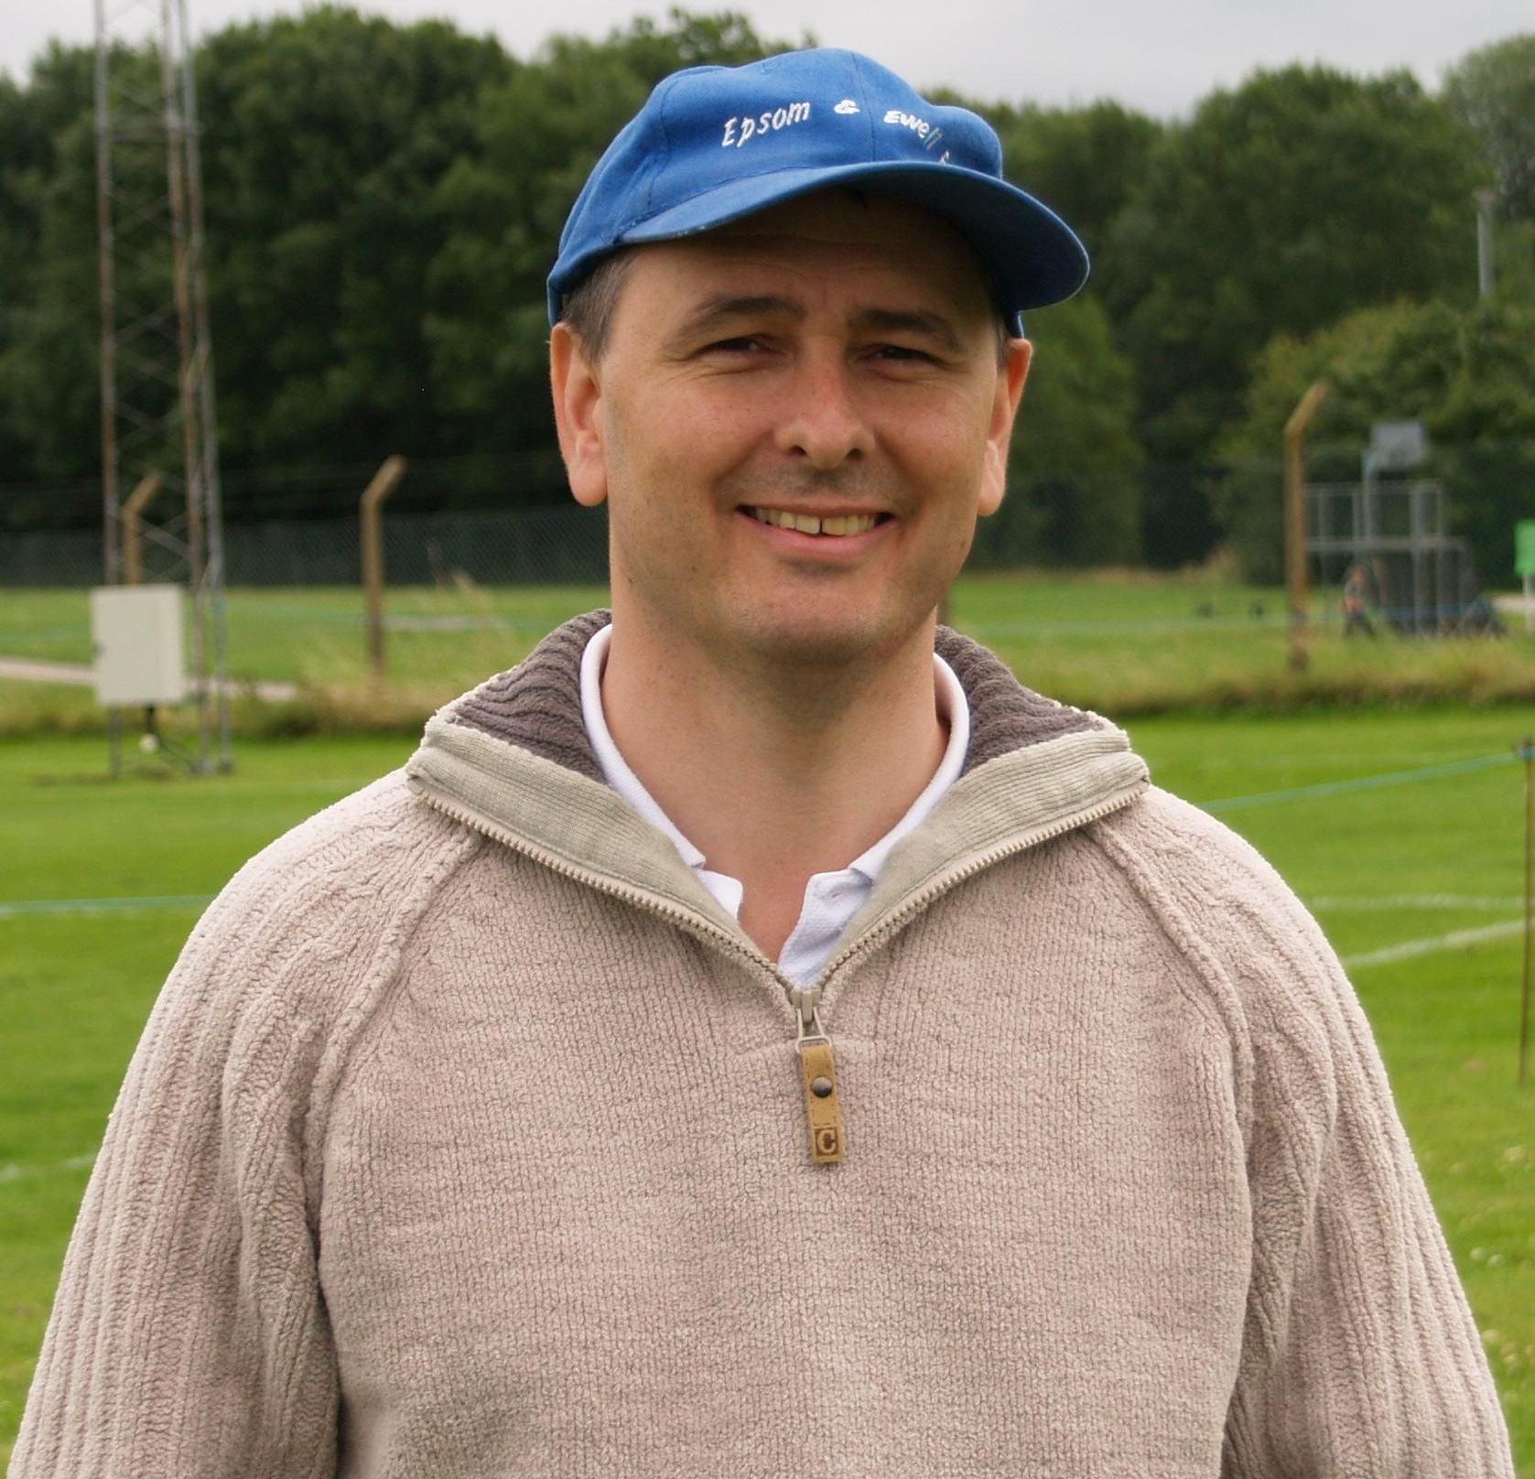
To try and get this list down to 100 has been an extremely difficult task. Occasionally I have put matches together for obvious reasons, as you’ll find out over the course of the season, and by the end of the season, we’ll find out which was top of the list.

91 – Epsom & Ewell 4-0 Clapton – Isthmian League Division One
Tuesday 28th April 1981

This day Tommy Tuite was making his 400th appearance, and it was quite clear that as he was sitting on 297 goals, a hat trick against lowly Clapton would get him to a significant milestone on the same evening. Although Tommy was by this time the all-time leading goal scorer, many would have thought at the time that he was also the record appearance holder too, which at the time, he wasn’t.

So there was much to celebrate, and no real pressure, as the faint hopes of promotion had faded, and third place was to be the Blues eventual finishing position. Either way, Clapton were on a hiding to nothing, and they trailed at half time inevitably to a goal from the little fella,

In the second half he scored again, and then, near the end, Epsom & Ewell were awarded a penalty. However, he refused the chance to score from the spot, and regular taker Jeff Hunn made it three-nil. With time running out though, Tuite scored his third and Epsom’s fourth to large cheers all around. That’s what I call timing!

90 – Badshot Lea 3-4 Epsom & Ewell – Combined Counties League
Tuesday 7th April 2009

This game won’t be remembered for its first half, which was dull and goalless at Cherrywood Way, home of Farnborough Town. However, the second half was unforgettable.

As supporters were just coming out of the tea bar and clubhouse refreshed from their half time break, they witnessed Dale Marvell hit a screamer into the roof of the net from around the twenty yard mark. The game hadn’t been restarted for long when Marvell scored again.

With twenty minutes remaining, and safe in the knowledge that Badshot Lea had caused us no trouble in the first half, thoughts behind the goal were turning to the next match, but we had forgotten about the inconsistent nature of our season, and in the space of fifteen minutes we conceded a penalty, and two further goals followed soon after to turn the game on its head.

With no time left on the clock a good ball in from the left was bundled in at close range by Robbie Burns to retrieve a point. Or so we thought. Within a minute, another great cross in from the left was met by a towering header…from a Badshot Lea defender, and the ball flew into the top corner to give Epsom the points that they had won, then threw away, and then grabbed back again, all in the second half. Mad!

89 – Epsom & Ewell 4-3 Eton Manor – London League
Saturday 26th August 1939

There are a lot of similarities with the game above, but this one just edges it on the list. Under the shadow of war clouds, this match was the opening match of the League season, and the closing match too! As with the Badshot Lea game, the score was goalless at half time, but the second half was much better for the Blues as they roared into a 3-0 lead, with two goals from H.E.Hook and one from the long-serving Jimmy Jones. However, totally against the run of the match at that point, the youngsters of Eton Manor fought back to equalise with minutes remaining. Just when it looked like it was a point dropped, up popped Hook in the 88th minute to score the winner and complete his hat-trick. World War Two was declared just eight days later, and this match would be the last one played by Epsom F.C. for just over six years.

88 – Windsor & Eton 2-5 Epsom & Ewell – Isthmian League Premier Division
Wednesday 10th April 1985

This is the first match in the list that is most memorable for an individual scoring achievement. Having said that, Tommy Tuite scored five times on other occasions, but they don’t make the list, so why does this match get in where others fail?

Put simply, this was in my opinion the best performance that Epsom & Ewell ever produced at this level, the equivalent nowadays of Step Two Conference South football. The Blues led two - nil at half time, but early in the second half, a lapse of concentration enabled the Stags to pull a goal back, then use that momentum to equalise shortly after.

However, our strikers had other ideas, and with Tony Boorman on the left, Steve Milton on the right, and Steve Hill in the centre with Tuite, they stormed back down the hill and restored the lead soon after; Tuite completing his hat trick. From that point onwards it was a riot, as the Blues dominated, and Tommy finished up with all five that day.

87 – The Whitehawk Quadrilogy – F.A.Amateur Cup 1969/70 season

In October 1969, Epsom & Ewell visited Whitehawk’s East Brighton Park ground for a first qualifying round tie in the Amateur Cup. The Blues trailed 2-1 towards the end, but a late Dave Morrish equaliser ensured a replay at West Street. However, a similar story ensued there, and even extra time couldn’t separate the teams, who again finished level at 2-2.

Four days later at neutral Queen Street, home of Horsham F.C. we led through Ken Jolly, but the Sussex outfit equalised before the end and extra time again failed to separate the teams.

For the third replay, the teams travelled back down to the site of the original tie, ad this time a first half Dave Morrish goal was the difference between two very evenly matched sides.

It was ultimately futile, as Tooting & Mitcham came to West Street in the next round and knocked us out 2-1. All we won that season was a fixture backlog!

Player Profile – Number 2 – Lyndon Buckwell
The third longest serving Manager in our history, Lyndon Buckwell, completes today’s profile.

Name: Lyndon Buckwell

Date of Birth: 9th January 1969

Birthplace: Kingston

Marital Status: Married to Lucy with a daughter Evelyn, who is three years old.

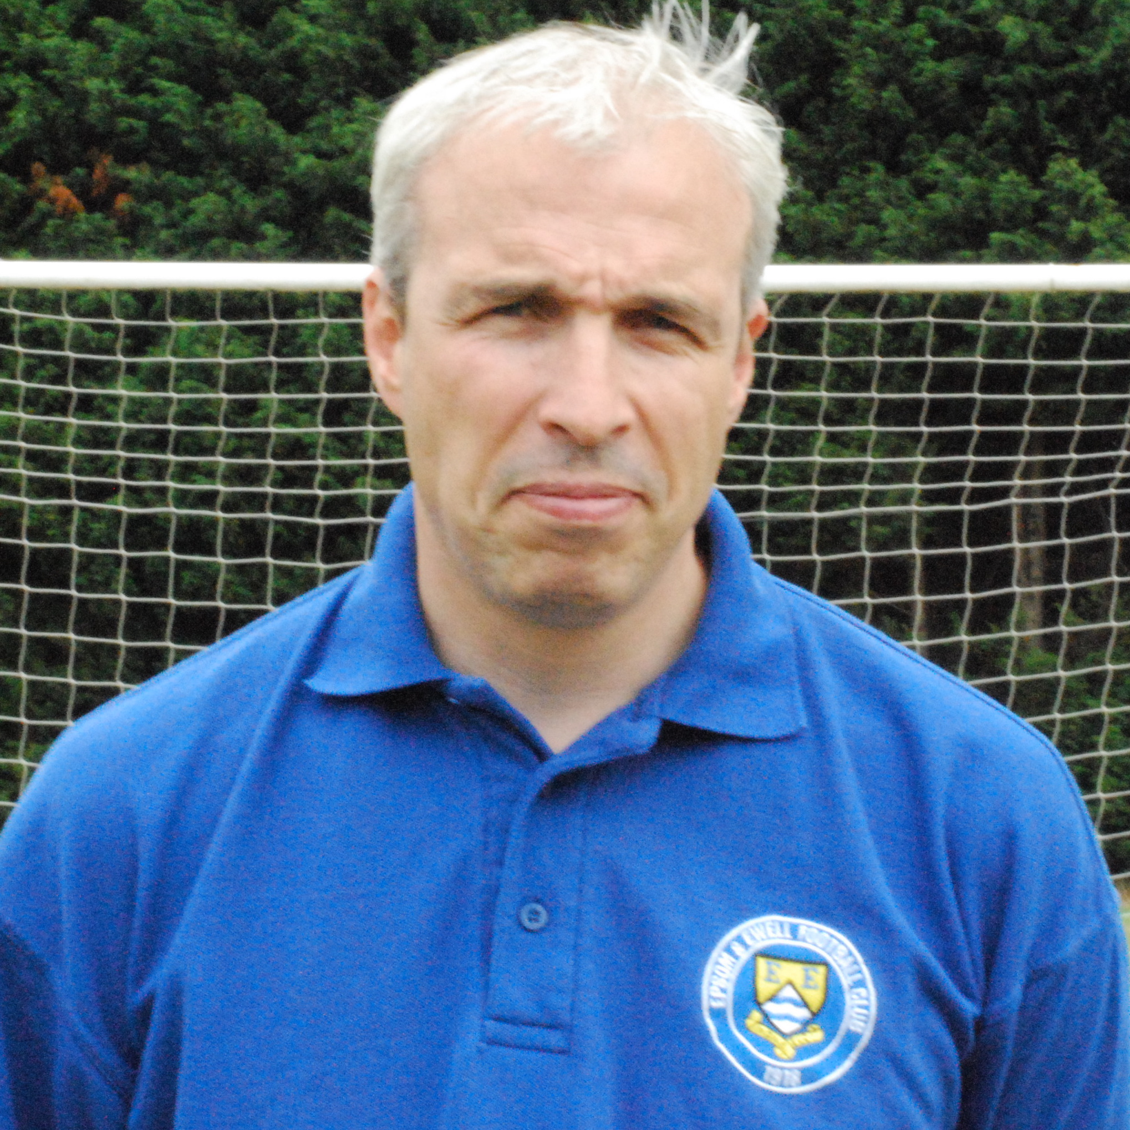
Favourite Football Team: Chelsea

Favourite Football Player: Xavi (Barcelona)

Favourite Ground: Camp Nou (Barcelona)

Favourite Food: Thai or Italian

Favourite Drink: Kronenburg 1664

Favourite sportsperson: Floyd Mayweather

Favourite Album: R,Kelly – 12 Play

Favourite Holiday Destination: Phi Phi Island (Thailand)

Clubs Played for: Epsom & Ewell, Kingstonian, Molesey, Hampton

Honours: Middlesex Senior Cup Winners (x 2)

Best ground you’ve played at: Kingfield, Woking F.C.

Personal aim for this season: To finish higher than last season, and not get sent off!!

Where will we finish in the League: Hopefully, Top. Realistically, Top Three.

Membership Form
Tony Foster is our new Membership Secretary. He would like to remind you all that your membership is due for 2010/11. Please either copy this form below or ask a Committee Member for another at today’s game. It is only £6 for adults and any cheques are to be made payable to Epsom & Ewell F.C.

If you want to post the form it goes to Tony as 396 Chessington Road, Epsom, Surrey, KT19 9EG.
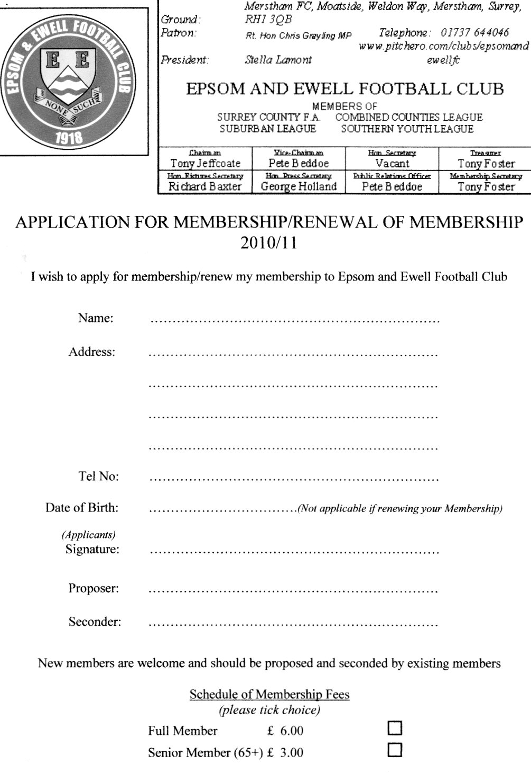

Apologies for the quality of the form, it didn’t scan very well!

Mole Valley SCR Club History
Chairman and Life President Alan Salmon founded SCR F.C in 1978, when the club began life as INRAD FC, based in Carshalton. The club entered a new era when Alan moved to Sutton and arranged sponsorship with his new neighbour, CENTRE 21 FC was born. This era saw the club running one Saturday side, three Sunday sides and three Youth sides. Centre 21's sponsorship continued until the club's youth players were no longer under 21 years old.

The club again sought new a identity, SUTTON COMMON ROAD FC was formed and subsequently abbreviated to SCR FC. Since then the club has had five major sponsors whose names have been incorporated into the clubs affiliated name: SCR PLOUGH (twice), SCR GRAPES, next the club's longest sponsor SCR LITTEN TREE (7 years) & finally SCR Kingfisher, Ewell with whom we started our venture in Saturday football in 204/05, until Andy Cox’s departure, the then landlord of the Kingfisher moved away from the pub to pursue new ventures. It was at this point that the club took the decision to revert back to using the SCR name alone

The club entered yet another new era this season, with the introduction of a third Saturday side and the 1’s moving to the Middlesex County FL (and a name change SUTTON COMMON ROVERS) in the pursuit of combined Counties football, having made an unsuccessful application from the Surrey South Eastern Combination at the end of season 2006/07 having finished joint top (3rd on goal difference… 1 goal… ARGH!!).

Harry Barrett continued to run the SSEC front side until Feb 2008 when several personal factors meant he had to step aside, paving the way for John Waddingham & Ben Jeffcoate to take the reigns as caretaker managers. A third place finish in the Middlesex County League Premier division in 2007/08 meant that our promotion to the CCL was not assured but months of hard work & determination from the management team SCR eventually secured a place for the first time in the clubs 30 year history at the league AGM in June 2008 and the reserves moved into the CCL reserve division under the guidance of Alex & Justin.

Darren remains at the helm of the 1’s with new additions Peter Hayne as assistant & Ken Bremner as club playing coach and returning Gary Brigden as goalkeeping coach. Season 2008/09 saw the latest name change of the club, the inclusion of “MOLE VALLEY” to form our current name, MOLE VALLEY SCR FC reflecting the area in which we play since migrating from the London Borough of Sutton. Season 2009/10 saw the club reach a Surrey Cup final, narrowly being defeated by Sutton United after a 1-1 extra time score line on penalties and in the same season compete in the FA Vase for the first time in our relatively short history.

We finished Champions of Division One at the second time of asking, narrowly piping Worcester Park to the post in a fine run which saw us finish 3 points clear on the final match of the season. Season 2010/11 sees yet another set of new challenges face us. Premier CCL football, FA Cup entry and competing in the Surrey Senior cup all for the first time. Our aspirations are realistic in terms of expectations, but as always we will look forward to whatever comes our way and face each challenge head on.

Our new Website
Do you like the new website?

Janice Pond has kindly stepped in to facilitate a move to the pitchero group of websites, and as you can see below, it looks very professional.

While our previous website was also good, this has a couple of advantages. Firstly it is a new look, which makes a nice change, and secondly, many people can update it, as access is being granted to all Committee and Playing Management.

To join up, all you have to do is enter the website and then join pitchero as a member (the link is up in the top left corner) and select the club name. From there you’ll be asked which categories of membership you require. Supporter or player would be your first box to tick, but there are other categories too.
Just go to http://www.pitchero.com/clubs/epsomandewellfc/ and you’ll see all of this.
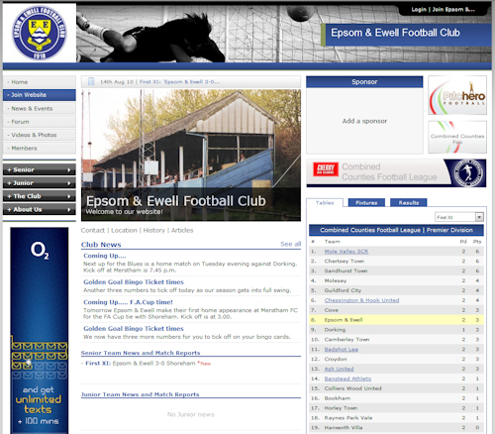

This page for appearances spreadsheet (centre pages)

This page for appearances spreadsheet (centre pages)

Golden Goal Bingo Ticket update
Following Tuesday’s win over Dorking, we all now have twelve different numbers to mark off on your cards. They are as follows:

Date | Comp | Opponents | H/A | F/T | Goal Times
07/08/10 | CCL | Sandhurst Town | A | 1-3 | 57
11/08/10 | CCL | Croydon | A | 3-0 | 13, 50, 55
14/08/10 | FAC | Shoreham | H | 3-0 | 10, 38, 45
17/08/10 | CCL | Dorking | H | 5-0 | 15, 36, 48, 71, 76
Here is everything you ever wanted to know about the Epsom & Ewell F.C. Golden Goal Bingo tickets:

This fund-raiser will run throughout the season in four separate scoring periods, the first of which is August and September. The cards cost £5 each and have twelve numbers on them.

For every competitive goal that the Blues score we will advise the minute of the goal on the web site and in the match programme.

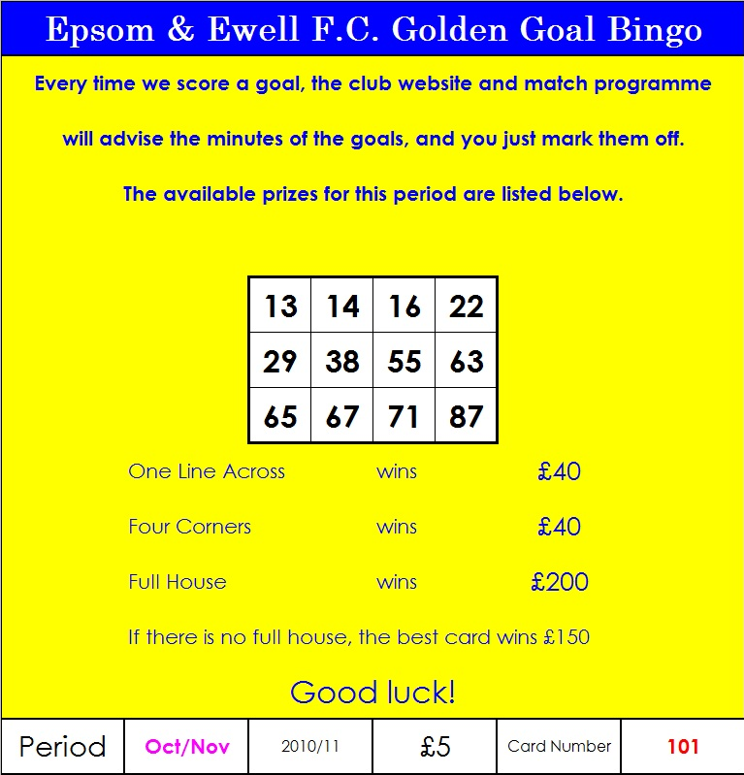
You simply mark the numbers off and claim your prize by producing the card. You can win by getting four numbers in an across line, or by marking off the four corners. Either way you can win £40, but the real prize is for the Full House, which is £200. Just in case a full house isn’t won, we will be aware of the nearest card and will advise its number accordingly. The winner of this “best card” will get £150.

These are big prizes, but they could get bigger still. It is down to everyone out there to sell as many tickets that they can. Even if just ten of you took ten to sell at work, then that would raise £500 towards the Fund-Raising Exercise.

There are terms and conditions, but they are fairly standard things, like having to be over 16 to play, and every ticket explains the claiming procedure. Just remember to hold on to them, as we will announce all winning numbers for the first scoring period in the first few days of October. Ticket number 101 is shown below, and as you can see it has already marked four numbers off, and it is still for sale in one of our 10 secret envelopes!


The Epsom & Ewell F.C. Fund-Raising Thermometer!
We currently sit at £645 at present. Ticket 101 is still for sale by the way, and will be in one of the envelopes tonight. Also, on sale today is the 50 Epsom Legends Book, which is on sale for £10 and is limited to 50 copies.

We will be announcing further fund-raising efforts in the near future so watch this space!

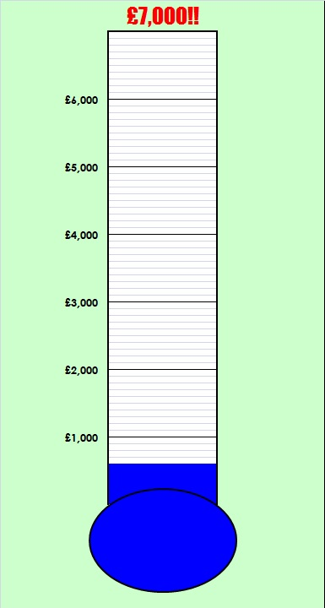

50 Epsom Legends
50 Epsom Legends

Today, we launch another Fund-Raising item, the 50 Epsom Legends.

Many of last season’s programme readers will have seen this series running, and counting down to the number one legend, Ernie Sperring.

In view of the feedback received, I thought it was worth putting all of the items into one place, and tweaking the list slightly, as it has evolved since I compiled the list some eighteen months ago.

So even if you read it religiously last time out, the order will have moved about a bit!

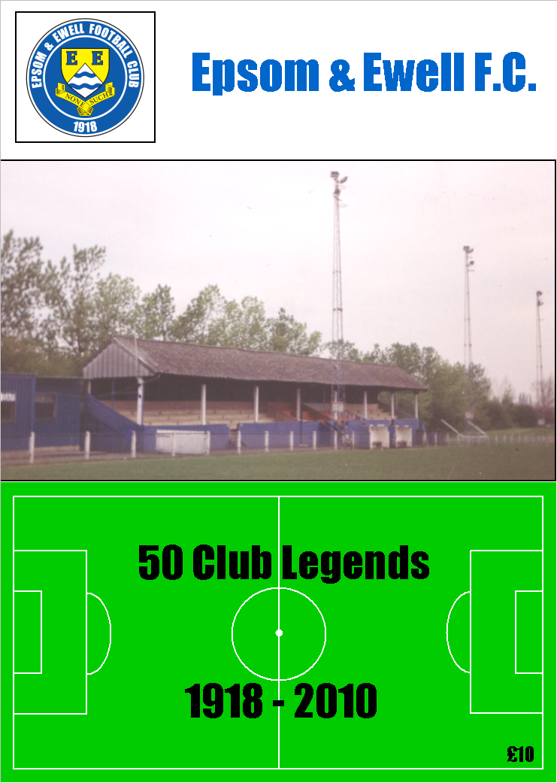
The cost of the booklet is £10, but it is 108 pages in length. In addition I have included the Epsom & Ewell F.C. Hall of Fame, showing the all time appearance lists and goal scoring lists. We have some current players on these lists, and hopefully they will continue to move up.

In addition, and this is the main crux of the Supporters Fund-Raising exercise, if you know anyone else who will be interested in purchasing one, please let me know, or purchase one for them. It might even make a handy early Christmas present!

This is also the same for the Golden Goal Bingo Tickets. If you can sell them to people outside the club, then we will raise more money. It is YOUR club, and it needs YOUR help, so please ask for details. It is not just a question of raising money between our group of supporters, we need to look outside too.

Stats and Sequences
Alex Rodrigues is still on an ever-present run. The last game he missed was on 1st December 2007, which was a 3-2 defeat at Cobham. The run is currently standing at 139 games, which is the third longest in club history behind Tommy Tuite (166 from 1973/76) and Dick Wilson (214 from 1932/36). If he remains fit, and avoids suspension, our Captain will surely claim the second place from Tommy.


Kyle Hough is our penalty king. He already holds the record for most penalties scored in a season (9 in 2007/08) and his current record of 21 consecutive penalties is now over double what the previous club record was. He has now scored 25 penalties for the club, which equals the record set in the thirties by Jimmy Jones and one more penalty will see him holding all three club penalty records.

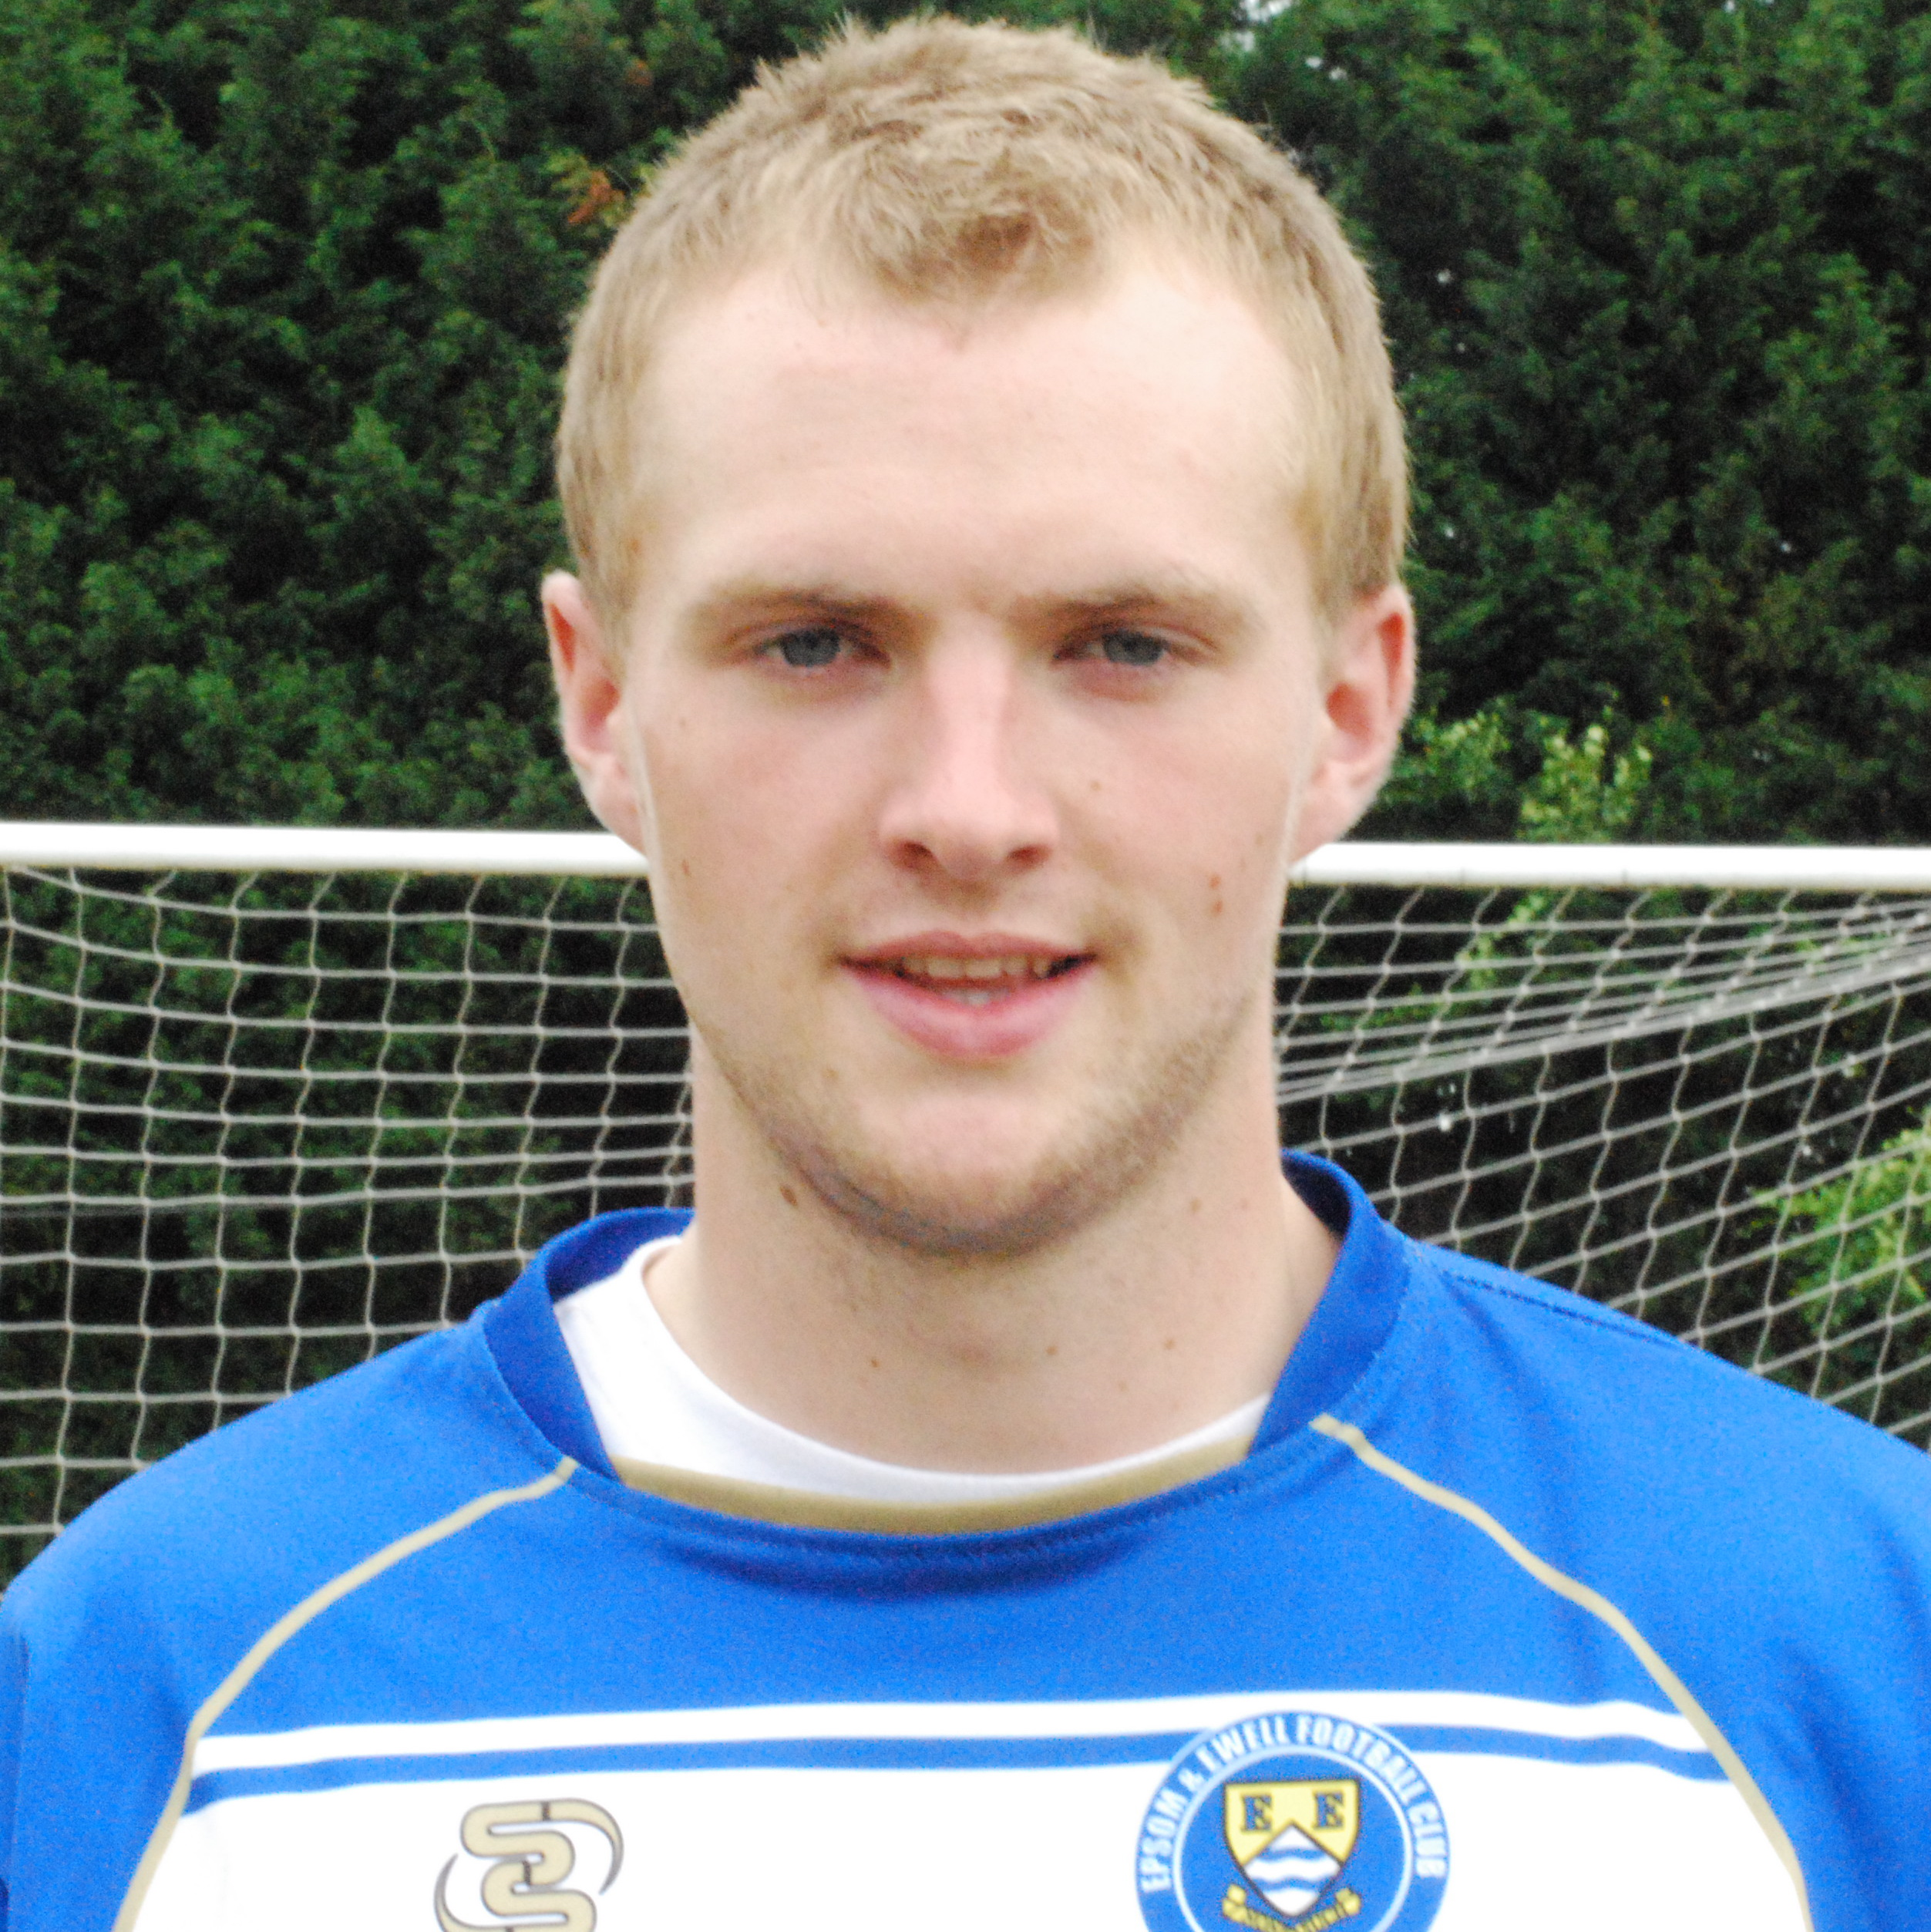
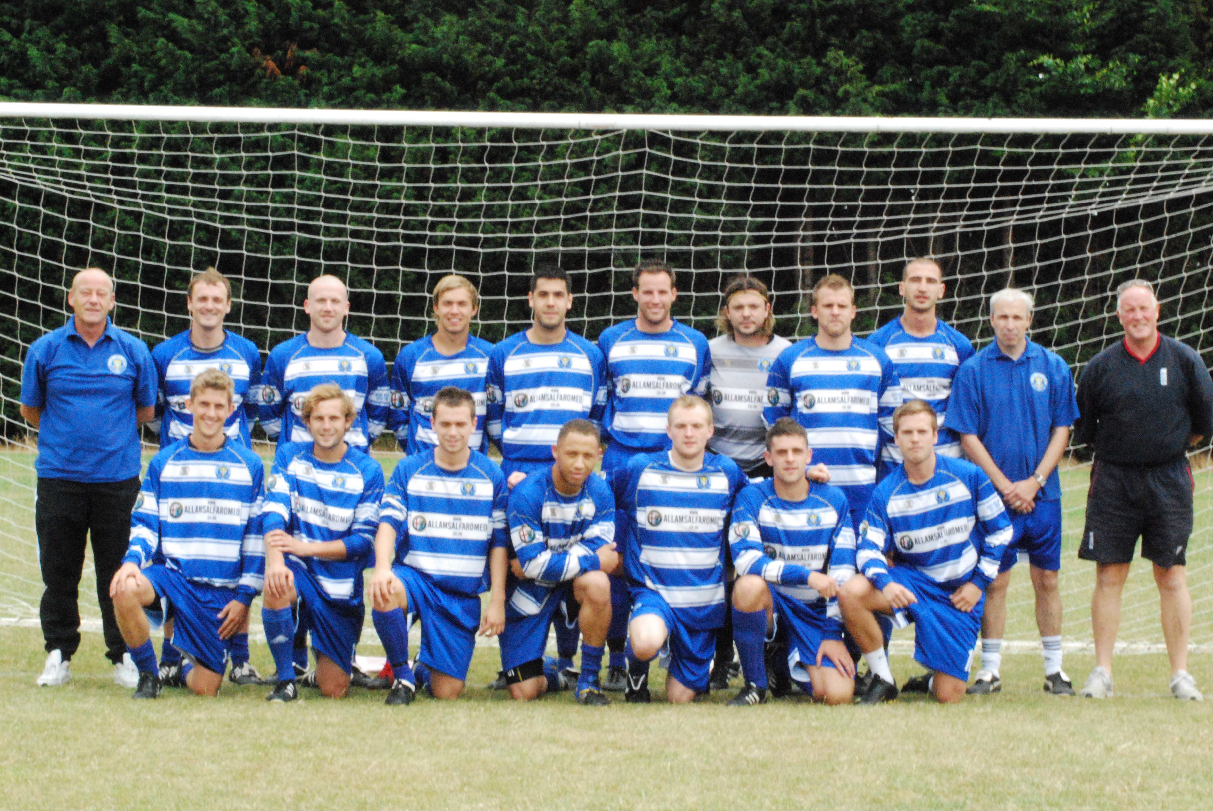
Team As regular supporters are aware, we have won our last three matches with clean sheets in each. Firstly, when was the last time we kept three clean sheets in a row? It was back in November/December 2008 with two wins and a 0-0 draw with Horley Town. Secondly, when did we last win three straight with three clean sheets? It was back in April 2003, when we defeated Chertsey Town (A) 3-0, Egham Town (A) 3-0 and Staines Town (H) 1-0. Bizarrely we did it in March of 2003 and February of 2003 too!!

The club record of straight wins and clean sheets is actually six, which occurred during our F.A.Vase Final season of 1974/75, between February 3rd and March 8th. We have also done five in March / April 1957 and four on just four other occasions, in October 1988, January / February 1980, August 1974, and September / October 1957, an elite group that we could join this afternoon.

Alan Carter
Today we have a new columnist in our ranks. Alan Carter has been a supporter since 2008 along with his son Jimmy. He started by going to both Epsom and Banstead home games, before eventually seeing sense and watching us! Before then he was a Wimbledon season ticket holder from 1995-2002 before their move out of the area, and says he prefers the football here! A self-confessed Ramzi Bedj Bedj supporter, his first contribution is below.

----------------------------------------------------------------------------------------------

SING WHEN WE'RE WINNING


Those of you at the Dorking game on Tuesday were treated to something very special. Something that was even more impressive than the five-nil demolition of our local rivals. A happening more spectacular than Kyle Hough's inch perfect penalty (literally!), Rodder’s typically committed tackling, or even the mighty-fine ball trickery that Ramzi Bedj Bedj treated us to.

Not even Tony Cuff’s terrific 76th minute corner, which sailed over the head of the hapless Dorking keeper to his total bemusement, can compare. By the way, just how brilliant was that goal? Even now I can hear Steve Davies shouting “shoot” every time we got into a crossing position thereafter - although at one point I thought the goalie was going to deck him!

I digress. Where were we? Oh yes the “event”. Now I’m aware that I‘m giving this occurrence the big build up, but I‘m sure you won‘t be disappointed. So let’s cut to the chase, what is it then that I'm banging on about?

The boys and girls behind the goal singing that's what! Yes you read that right… singing!

What do you mean you feel let down? I haven’t led you up the garden path. We WERE singing. OK, granted, we weren’t singing very well, in-tune or even very loudly but we were singing all the same. That’s how good the performance by the lads was.

And lets be honest, it’s not often those of us gathered behind the goal spontaneously burst into song. The last time this happened was our last “home” game at Merland Rise against Camberley Town back in May when Steve Dyke led three renditions of "we’ve got to get out of this place" by the Animals! A truer word that has never been spoken (or sung) as it goes - I mean just how much nicer is Merstham’s ground to Banstead’s?

Anyway, this momentous happening - us singing - got Evan Gregory (the man with the hat) and myself thinking about what our first official Epsom & Ewell song should be. Thinking on his feet, and having taken in our new surroundings, Evan came up with “Oh, it’s so nice to be beside the moat side” to the tune, funnily enough, of “Oh, it’s so nice to be beside the seaside”! Yes, Evan really is a comedy genius – OK, maybe not, but I’m not going to be the one to tell him! (You just have – Ed!)

Then, so as to add to the Carnival atmosphere, Evan and I had a go at “it’s just like watching…BLACKPOOL” – well, we were 4 nil up at the time!

Now on reflection, and having read back this article, I think Evan, the masses behind the goal and I should stick to shouting C'mon Epsom in future!

Steve Dyke
I’ve been listening to the Man United v Newcastle game and one of the great stat-clichés has already been dealt with this season. Ryan Giggs scoring has meant the “he has now scored in every season since time begans” are out of the way on the first game.

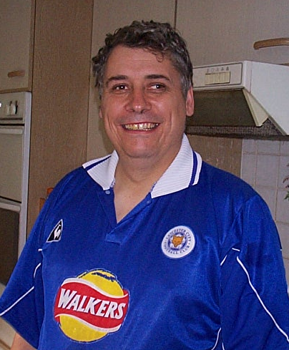
I exaggerate slightly because those who promote the Premier League sometimes talk and use stats in a way that would have you believe that football only began in 1991-92 and nothing of any significance happened before. No Dixie Dean 60 goals in a season; no Stanley Matthews playing into his fifties; some of those records will never be broken. Particularly nowadays when the better teams operate squad rotation anyway.

I didn’t realise this at the time I was studying the research stats module at university and scraping through with about 42% but I do secretly love stats. One of the compliments we have received about this programme is the breadth and depth of stats and history. That’s all down to Richard; he does all of this and he’s never had to mooch around in a dressing gown having the mickey ripped out of him by Frank Skinner.

I love watching our player’s stats starting to increase. One of the sadnesses for me if Robbie Burns isn’t with us this season is that he won’t go through the 100-goal mark for our club. As ever in football this creates an opportunity for others. By the time you read this potential cult hero Mark Jarman may be in double figures. Jaaaarmo! Jaaarmo! – he’s already nearly there for me after his two great goals last Saturday.

Richard has done a fantastic thing in charting our club history. The stats give proof that people actually did what they said. Last year I bumped into former player and cult hero Joao Tome as he was plastering a house across the road from someone I know. He asked me to come across and tell his workmate that he’d been a good player (albeit for just one season). I pointed him in the direction of the book. I was talking to Ada Hill (Legend No 4) one time about the book and he said the best thing about it was he could prove to his grandchildren what he had done.

Blimey this article is getting a bit Michael Winner “as I was saying to Roger Moore over lunch yesterday “ I’d better watch myself .. back to the main point. Back in 1991-92 when Giggsy –Wiggsy was a mere spotty youth, I was quite involved in a group called the FSA (Football Supporters Association) South Yorkshire branch. At the time the Premier League was breaking away from the rest of the football league, and the FSA opposed it as a charter for big club greed and that resources should be better shared throughout the game. That’s why each win in the F.A. Cup is so good as it is little Epsom’s main chance to share in that booty. Things have turned out to be quite absurd when Manchester City are reportedly paying Craig Bellamy six times my annual salary per week NOT to play.

The Premier League chairmen who carried out that resource grab at the time said no, no, this is not mere selfishness on our part. Our only desire is to create an excellent England team. Yes, some of us have very long memories. It’s a trait in human beings that can be negative, as in Northern Ireland politics, or positive as I remember the Tommy Tuite’s and Stuart Miller’s. In future I’m sure I will be boring people floppy with the feats of A Rod, Mark Jarman, Ramzi Bedj Bedj and co.

One of the exciting things about this season so far is we appear to have improved what was already a pretty good team .Our players have the chance this year to make themselves legends and cult heroes. Let’s enjoy the history continuing to unfold.

Scouting the Opponent – Flackwell Heath
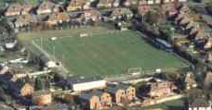
Historically, we know our next F.A.Cup opponents well, as we met them twice each season, from 1987/88 to 2001/02 and again from 2004 to 2006 totalling 34 meetings in all. Matt Elliott scored the winner in the first meeting, and he scored again in the 5-1 return win at West Street in May 1988, which was of course his last game before turning professional with Charlton Athletic. We also celebrated promotion to the Isthmian League Division One there with a 2-1 win in May 2002.

Since our paths separated, they have had a brief dalliance with Step Four football, before dropping back into the Hellenic League, where they have made a poor start, losing 3-0 at home to Abingdon Town, and 2-1 at Wokingham and Emmbrook’s temporary ground at Larges Lane, Bracknell. Their one win so far this season was in the previous round of the F.A.Cup, when a winning goal eight minutes from time was enough to see off Sussex Division Two team Oakwood by two goals to one.

However, be warned, the club broke their record at the end of the season with a fifteen game unbeaten run, and they have a similar squad this season.

Hellenic League Premier Division – 2010/11
Inc Wednesday 18th August | P | W | D | L | F | A | Pts | GD
Ascot | 3 | 3 | 0 | 0 | 11 | 4 | 9 | +7
Slimbridge | 3 | 2 | 1 | 0 | 5 | 2 | 7 | +3
Reading Town | 2 | 2 | 0 | 0 | 7 | 4 | 6 | +3
Ardley | 2 | 1 | 1 | 0 | 6 | 3 | 4 | +3
Abingdon Town First Team | 2 | 1 | 1 | 0 | 3 | 0 | 4 | +3
Binfield | 2 | 1 | 1 | 0 | 3 | 1 | 4 | +2
Bracknell | 2 | 1 | 1 | 0 | 3 | 1 | 4 | +2
Kidlington | 2 | 1 | 1 | 0 | 3 | 2 | 4 | +1
Wokingham | 3 | 1 | 1 | 1 | 4 | 4 | 4 | 0
Shortwood | 1 | 1 | 0 | 0 | 4 | 0 | 3 | +4
Wootton Bassett | 1 | 1 | 0 | 0 | 2 | 0 | 3 | +2
Old Woodstock | 2 | 1 | 0 | 1 | 6 | 7 | 3 | -1
Wantage | 2 | 0 | 2 | 0 | 4 | 4 | 2 | 0
Witney | 2 | 0 | 1 | 1 | 2 | 4 | 1 | -2
Fairford | 1 | 0 | 0 | 1 | 2 | 3 | 0 | -1
Thame | 1 | 0 | 0 | 1 | 1 | 2 | 0 | -1
Pegasus Juniors | 1 | 0 | 0 | 1 | 0 | 2 | 0 | -2
Shrivenham | 2 | 0 | 0 | 2 | 1 | 4 | 0 | -3
Flackwell Heath | 2 | 0 | 0 | 2 | 1 | 5 | 0 | -4
Highworth | 2 | 0 | 0 | 2 | 1 | 5 | 0 | -4
Carterton | 2 | 0 | 0 | 2 | 1 | 6 | 0 | -5
Oxford City Nomads | 2 | 0 | 0 | 2 | 2 | 9 | 0 | -7

Steve Davies
What Football could learn from – Baseball

Welcome to the fist instalment of this “What football could learn from….” Mini-series where we look at the American National Sport of Baseball and ask if any of its rules, regulations, traditions or practices could be implemented in football to our National Sport’s benefit.


Firstly, it is amazing as to how many expressions in every day use derive from Baseball. If you have been asked to “step up to the plate” and come up with a “ballpark” estimate or you may decide to “cover all your bases” or had to deal with something “coming out of left field” to “get past first base” or simply play “hardball” and heaven forbid you should ever “drop the ball“ or “muff“ a shot.

Is your company “in the big leagues” or have you ever taken something “on the fly”, thrown a “curveball” or postponed a meeting with someone to “touch base” by “taking a rain check”. A new event which is intended to be “a brand new ball game” could be a “hit or miss”. You may get a “Whiff” (when a batter swings and misses) of a “Grand slam” or get “Brushed back” during a “double header”. Also, the expression “Going, going, gone!” was first coined by a Baseball commentator.

Compared to this it is quite astonishing as to how few expressions that are derived from football. I can only think of “kick off” (as in, let’s kick off this meeting!), “red carded” referring to someone banned or not allowed to participate in something, and (stretching it!) the “back of the net!” catchphrase made famous by fictitious chat show host Alan Partridge (alias Steve Coogan).

Now, a game of baseball starts with the away team batting first. What if the coin toss in a game of football was dropped and instead the home team was entitled to choose which direction to kick and the away team automatically kicked off. This would ensure that the home team could attack their favourite end in the second half (if they wished) and the fans could choose their seats when purchasing season tickets with this in mind. Personally (being a “behind the goal” man) I would choose always to sit behind the goal my team was attacking in the second half.

A Baseball match is split into 18 segments, 9 innings that each have a “top” half (when the away team bats and the home team pitches) and a “bottom” half when the teams switch roles. I am not going to suggest that there should be a break every five minutes during a match (though this would clearly assist on the occasions where I have downed 4-5 pre-game pints!) but I do believe that something should be done about the seemingly constant stoppages that are seen during the second half of matches, which is especially frustrating if your team happens to be losing.

Back in the days of only one substitute per team being allowed, this was never an issue but now that up to six substitutions can be made, it really ruins the latter stages of many matches (and how I do hate the obligatory tactic from the winning team of bringing on a sub in injury time just to elapse a few more seconds). How about if the referee blew his whistle after 60 minutes and again after 75 minutes and these

were the only times that a sub could be brought on during the second half?

Looking now at equipment, if baseball fielders wear outrageously outsize gloves to assist in catching fly balls should we allow goalkeepers to wear size 88 gloves, which could cover half the area of the goal? Maybe only if we wish almost every game to finish goalless! Actually, it does seem that the size of goalies gloves over the past 30 years has steadily increased. Peter Bonetti, the Chelsea and England keeper had thin cotton gloves (I had a pair when I played in goal for Epsom Eagles under 13’s and I would have done better to wear a couple of banana skins which would have given me more grip!). The Germans, always looking for ways to gain an advantage came out with the “Sepp Maier” Gloves. Maier was the legendary West German and Bayern Munich keeper who picked up a world cup winners medal in 1974, and gave the impression that his hands were twice the size and seemed to be the first in a trend of large gloves with rubber suction pads over the palm and finger areas.

Baseball can be a long game. The shortest ever game recorded was 55 minutes but it’s rare to see a game end in under 2 and a quarter hours, with 3 hour plus game commonplace.
A tradition that allegedly dates back to 1869 is the “Seventh Innings Stretch” where the crowd is encouraged to stand up in the middle of the innings and dance or stretch around to a catchy song, the word of which usually appear on the giant video screen that pretty much all ballparks now have installed. Would this work in football? Supposing the game was to halt for a few minutes after 67 minutes of play (possibly to allow substitutions similar to a previous idea detailed above) but mostly to allow the managers a brief team talk to guide their side through the final quarter of the match but also to allow the spectators to take a quick toilet or tea break!

During either quiet spells in a game, or during a potential rally from the home team the stadium organist would play a few bars of a specially chosen tune, such as the theme to “The Addams Family” which always gets the crowd clapping twice at the appropriate moment or the “charge” theme in the event of a rally. How about a few bars of a tune when Epsom, say win a penalty, corner or a free kick just outside the box? Would that lift the mood of the crowd? Finally, how about introducing the good old baseball tradition of charging $10.75 for a glass of draught beer and $6 for a slice of pizza?

To Summarise:
Drop the coin toss: My vote = YES
Allow subs to be made only at 60 minutes and 75 minutes: My vote = YES
Allow goalkeepers to wear outrageously outsize goalkeeping gloves: My vote = NO
(Actually, I am not even sure if there is a regulation limiting the size of gloves)!
Stop the game on 67 minutes for a short 5 minute break: My vote = NO
Play a few bars of a pre selected tune when a penalty, corner or dangerous free kick is awarded: My Vote = NO (But I am in favour of a tune after an Epsom goal!)
Outrageously expensive Beer and Food: My vote = Over my dead body!

I’ll be back with the next in this series with “What Football could learn from………….Synchronised swimming! (well, perhaps not! but we will take a look at another sport.)

Every Opponent A-Z
Over the years we have played many, many different opponents. Exactly how many is a difficult question, as it all depends on your definition. Are Camberley and Yorktown different to Camberley Town, or are Epsom Town different to Epsom F.C. or Epsom & Ewell F.C.?

In my analysis I have classed them as the same team, and will work through them all from A to Z. Some we have played many times, whilst others maybe just once or twice. Enjoy!
-----------------------------------------------------------------------------------------------------------------

Aldershot Services:
Played 2 - W0, D0, L2 - F1, A5
Points per Game - 0.00

I’ll be honest. I know very little about Aldershot Services. We travelled to their ground twice for Southern Combination Cup ties, losing 4-1 in September 1971, and 1-0 in October 1975. Even the goal we scored was an own goal!

Aldershot Town: - Played 3 - W1, D1, L1 - F4, A3 - Points per Game - 1.33 Average

Aldershot F.C. folded in the middle of season 1991/92 due to financial issues, and resigned from the League. They reformed for the 1992/93 season as Aldershot Town and with the aim of returning to the Football League, but were placed way down the football pyramid in the Isthmian League Division Three. This was of course a major benefit for clubs in our division, as they would obviously bring large support and revenue.

We first met the Shots at the Recreation Ground on 21st November 1992, and in front of 1,946 spectators conceded a first half goal that looked offside to me. However, we were never going to get a message through to the referee, and it got even more absurd in the second half when we were placed in the segregated away end. Six of us!

Our players must have heard us, or felt pity, and in the second half we equalised through Andy Nimmo and held on for the draw, but in the April of 1993 they visited for the return fixture, and defeated us 2-1 in front of 1,500 present for the last ever League match at the old venue.

Aldershot Town clinched the title that day and were duly promoted, but we got another crack at them in the Associate Members Trophy the following season. We again travelled down to the Hampshire border and were ahead after a few minutes through an early own goal. We held on, and Nigel Webb made the game safe in the second half for a famous win.

Aldershot Traction: - Played 2 - W1, D0, L1 - F5, A5 - Points per Game - 1.50 Average

We only played Aldershot Traction twice in the Surrey Senior League for 1926/27. We travelled down there on Boxing Day, where we won 4-1 after a goalless first half, but they gained revenge at West Street by the same score line on Easter Saturday 16th April. This was harsh on our boys, as they had been required to play at Egham on the Good Friday and had a big friendly match with Sutton United two days later, so maybe they were a little tired! The Aldershot Traction side finished in third place that season and remained in the League for 1927/28 but disappeared from the League at the end of the season, with Epsom by that time in the London League.

T
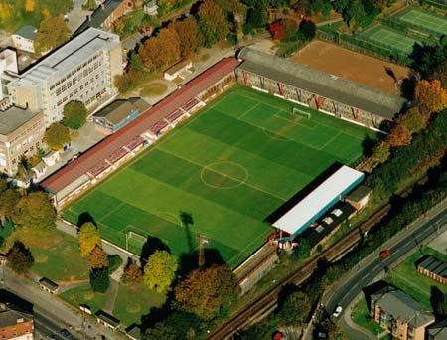
The Aldershot Recreation Ground

Alton Town: - Played 2 - W0, D0, L2 - F0, A3 - Points per Game - 0.00

We didn’t even register a goal in our two Athenian League Division One matches right at the end of the 1976/77 season. We lost one-nil at West Street on a Thursday night in a game where Bobby Page missed a penalty, and nine days later we were defeated 2-0 at Anstey Park.

The club merged with Bass Alton in 1990 and now play around the corner from their old ground, which is now used by the local rugby club.

Altrincham: - Played 1 - W0, D0, L1 - F0, A1 - Points per Game - 0.00

Altrincham were the two-time reigning Champions of the newly formed Alliance Premier League when our paths crossed in the F.A.Trophy Second Round. Although they were to lose their title to Runcorn that year, they were still the most famous non-league side of the last fifty years, and would reach the Final of the Trophy that year, losing to Enfield.

Approximately 900 were present at West Street on 6th February 1982 for the glamour tie that our boys had earned, following wins over Alliance Premier Gravesend & Northfleet, and Southern League (at the time) Cheltenham Town, both on their own patches. Unfortunately it was not to be our day, having three good penalty shouts turned down, only to lose to a speculative shot from twenty-five yards that took a wicked deflection past our keeper Ian Finch. After a few sticky seasons, the Manchester club are now back and settled in the National Conference and are probably due another cup run!

Combined Counties League Cup Draw
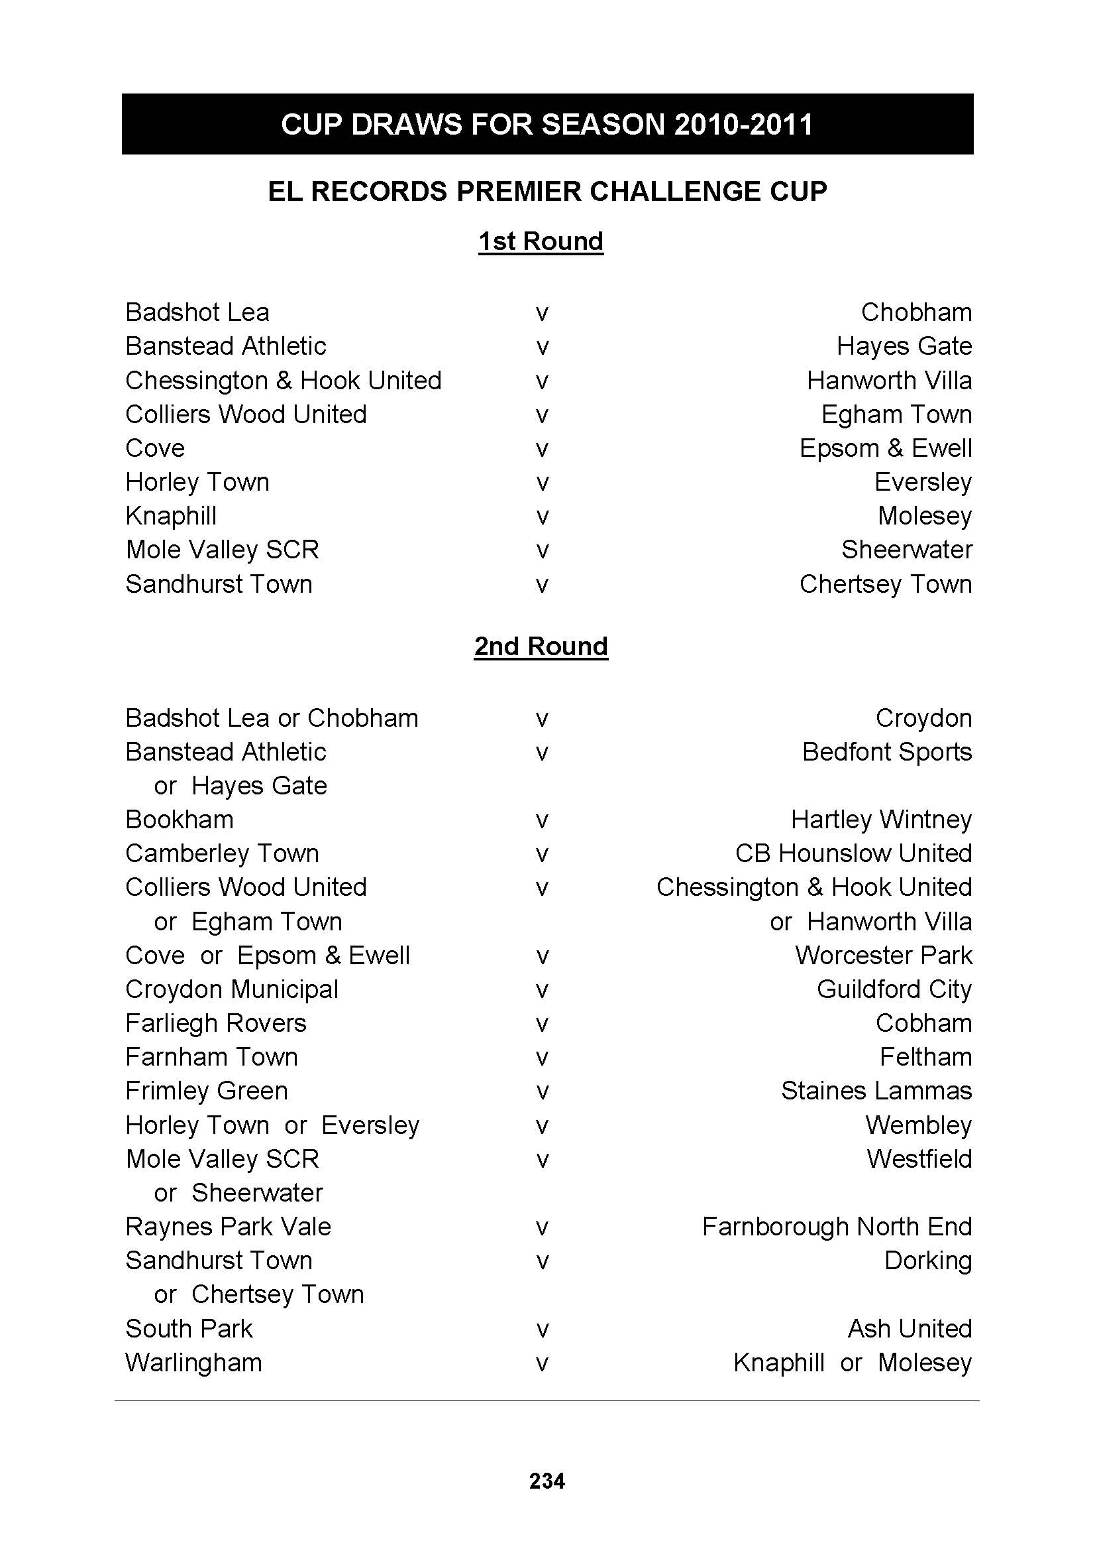
We meet holders Cove at Oak Farm on Tuesday 21st September. Why not come along and see if we can ensure that their hold on the trophy is a short one!

Player Sponsorship
 |   Shirts (£25.00) |   Shorts (£12.00) |   Socks (£8.00)
The cost is shown by each item, or you can sponsor
a player for £40.00. Speak to Tony Jeffcoate.

Ramzi Bedj Bedj
Paul Borg
Tony Cuff | Bob Clarke
Matt Fowler

Neil Harrowing

Jamie Hatfield

Ben Hayward
Kyle Hough
Mark Jarman
Tom Jelley
Alex McGregor
Joe Paris
Jamie Reive
Alex Rodrigues
Dean Sammut
Ross Shoefield
Darren Smith | Barry Barnes
Matt Smith
Peter Solomon
Richard Webber
Ben Ward
Charlie West | Paul Norris
Paul West | Paul Smith
Lyndon Buckwell
Tony Coombe
Ken Jones
Barry Barnes

This Season’s Match Sponsors
Fixture | Date | Match Sponsor | Ball Sponsor
Shoreham (F.A. Cup) | 14/08/10 | Epsom & Ewell F.C. Committee
Dorking | 17/08/10 | Pete Beddoe
Mole Vallley SCR | 21/08/10 | Richard Lambert
Flackwell Heath  (F.A. Cup) | 28/08/10 |  | Dick & Dom
Banstead Athletic | 07/09/10
Guildford City | 11/09/10
Ash United | 28/09/10
Molesey | 09/10/10
Badshot Lea | 23/10/10
Raynes Park Vale | 06/11/10
Cove | 20/11/10
Croydon | 04/12/10
Chessington &  Hook United | 11/12/10 | Freeman, Hardy & Willis
For League Matches:

Match sponsorship is available for £35.00.

Match ball sponsorship is available for £20.00.

For Cup Matches:

Match sponsorship is available for £45.00.

Match ball sponsorship is available for £25.00.

Match sponsorship includes admission,
programmes, advertising and hospitality for two.

Match ball sponsorship includes admission,
programme, advertising and hospitality for one.

Interested? Speak to Tony Jeffcoate on 07960 084225 now!

Photo of the week
Gemma’s latest photo is twofold. It shows Mark Jarman scoring the first goal in the F.A.Cup tie against Shoreham, while in the distance I have just been stung on the back of the neck by a wasp!

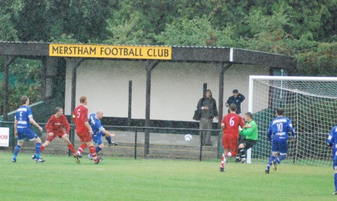

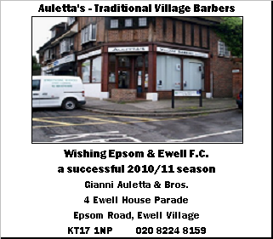

Combined Counties League – Premier Division
Tuesday 17th August 2010 - Kick-off 7.45 p.m.
Epsom and Ewell F.C.  (Royal Blue & White hoops) | V |  |  | Mole Valley SCR  (All red)
Neil Harrowing | 1 |  | 1 | Leigh Bowden
Dean Sammut | 2 |  | 2 | Anthony Guiney
Jamie Hatfield | 3 |  | 3 | Dan Martyn
(capt) Alex Rodrigues | 4 |  | 4 | Paul Whitthread
Charlie West | 5 |  | 5 | Aaron Smith
Joe Paris | 6 |  | 6 | James Cottrell
Kyle Hough | 7 |  | 7 | Richard Smith
Tony Cuff | 8 |  | 8 | Darren Evans
Mark Jarman | 9 |  | 9 | Matt Kilty
Darren Smith | 10 |  | 10 | Tyrone Roberts
Ramzi Bedj Bedj | 11 |  | 11 | Danny Clayton
Tom Jelley | 12 |  | 12 | Liam Holden
Paul Borg | 13 |  | 14 | Nehemiah Adams
Chris Read | 14 |  | 15 | Taylor Mollatt
Matt Fowler | 15 |  | 16 | Jayde Spence
Alex McGregor | 16 |  | 17 | Luke Jones-Whittaker
Lyndon Buckwell | MANAGER |  |  | Darren Salmon
Tony Coombe | ASSISTANT |  |  | Tony Webb
Barry Barnes | COACH
Ken Jones | PHYSIO |  |  | Tony Williams
REFEREE: I.Kitchen (Woking)
ASSISTANT REFEREES: M.Coen (Worcester Park), P.Stevens (Streatham)
Today’s Match Sponsor is Programme Editor Richard Lambert

OUR NEXT FIRST TEAM MATCH AT MOATSIDE

Epsom and Ewell v Flackwell Heath

Saturday 28th August - Kick-off 3.00 p.m.

F.A.Cup (sponsored by E.on) – Preliminary Round

